The plant can be controlled via the LCD screen.
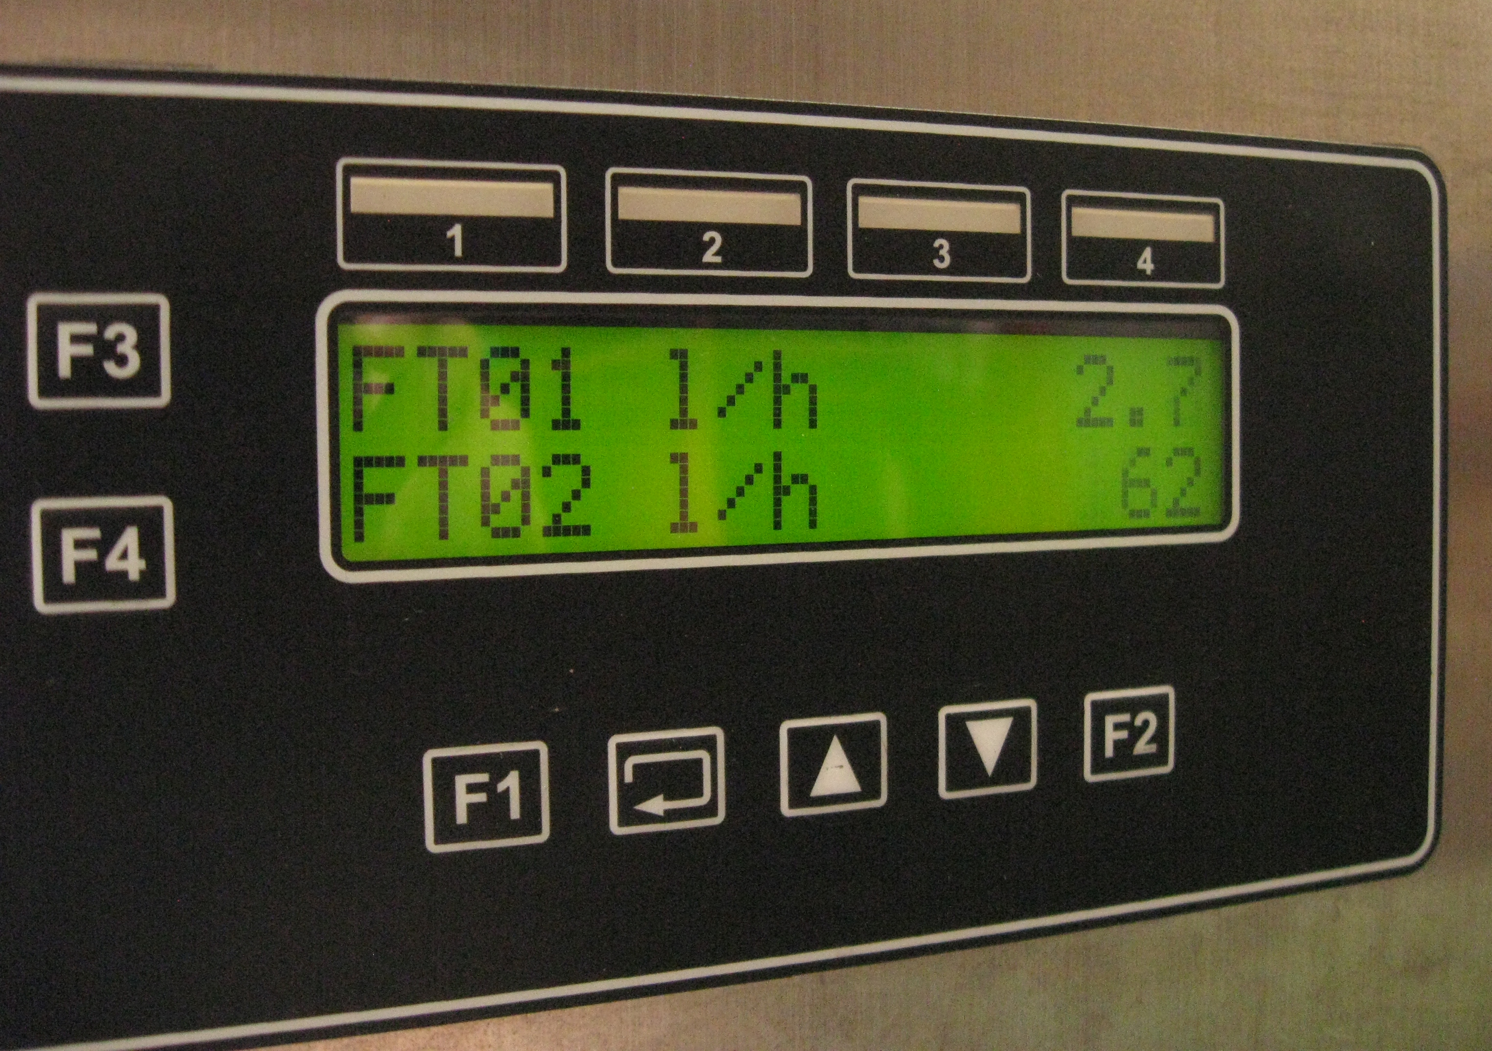

The up and down arrows scroll through the different pages of the display.

The state of the plant can be understood by observing the second line of the second page. The second line alternates between displaying the time spent in the current state, a description of the current state, and a message explaining any faults.

Certain pages allow the modification of parameters. Press both the F1 and F3 buttons together to move to edit mode. In edit mode, press the up and down buttons to change the parameter’s value. Once the desired value is shown, press the enter key (immediately left of the up button) to set the new value.

The plant will process product until a certain concentration factor has been obtained. For example, if you wish for a two-fold concentration of the product, set the concentration factor to 2.00. If the plant stops because the desired concentration has been reached, it will display a message indicating this.

The last display page specifies the control algorithm. The original algorithm was designed for the use of all eight membranes, however if the alternative pipework is installed such that only one membrane is used, then the control algorithm needs to be changed. The original (8-membrane) algorithm is specified by setting the control algorithm to zero. The single-membrane algorithm is specified by setting the control algorithm to one.

Original Control Algorithm (#0)
When eight membranes are installed, the permeate flow is able to be reliably measured by FT03. The control algorithm has three important process variables: the differential pressure along the membranes (DP12), the proportion of flow through the permeate line compared to the retentate flow (R13), and the proportion of flow through the bypass line compared to the permeate line (R21).
The setpoints associated with the process variables are DPC12SP01, R21SP01, and RC13SP01. These need to be set before the production process is started.

Single-Membrane Control Algorithm (#1)
When a single membrane is installed, the permeate flow measurement via FT03 is not reliable. This control algorithm has three important process variables: the differential pressure along the membranes (DP12), the proportion of flow through the bypass line compared to the retentate flow (R23), and the desired pressure (PT01).
The setpoints associated with the process variables are DPC12SP01, RC23sp, and PC01sp. DPC12SP01 needs to be set before the production process is started, however RC23sp and PC01sp should be set during processing.
The operator should observe the flow of the permeate. If an increase in permeate flow is desired, the pressure setpoint PC01sp should be increased. However, it is important not to increase this value too quickly. Moving the value by one bar is acceptable. Once the value is changed, the operator should observe R23 to ensure that the system is stable before further increasing the operating pressure.

